SIMPLE

LOGIN SYSTEM

PROJECT DOCUMENTATION

GROUP BY:

1. Fernandez, Kevin

2. Sase, Jusper

3. Lu, Jame Lyle Santino

4. Gendrala, JohnMhar

5. Ellana, John Lester

SECTION: BSIT 2-11

SUBJECT: INFORMATION TECHNOLOGY

INTRODUCTION

The Simple Login System is a web-based application designed to provide a simple and organized way to register, authenticate, and manage user accounts. It is developed using PHP for server-side processing and MySQL for storing and managing user data.

The system allows users to create an account, log in securely, access a dashboard, view registered users, edit user information, delete user records, and log out of the application.

This project is created as a learning activity to demonstrate how PHP, MySQL, HTML, and CSS work together in building a functional web application. It also helps in understanding basic concepts such as database connectivity, form processing, session management, and access control.

In short, this system provides a basic and functional solution for user account management while serving as a hands-on project for learning web development and database operations.

PROJECT PURPOSE
What problem does it solve?

Problem: Disorganized user records
Managing user information manually can make it difficult to find, update, and remove records.

Problem: No login validation
The application needs a way to check submitted usernames and passwords before allowing access to the dashboard.

Solution: Centralized user management
The system stores account records in MySQL and provides functions for viewing, editing, registering, and deleting users.

What is the project for?
It is intended for basic user account management and as a learning project for practicing PHP programming, SQL database operations, and web application development.

System Architecture
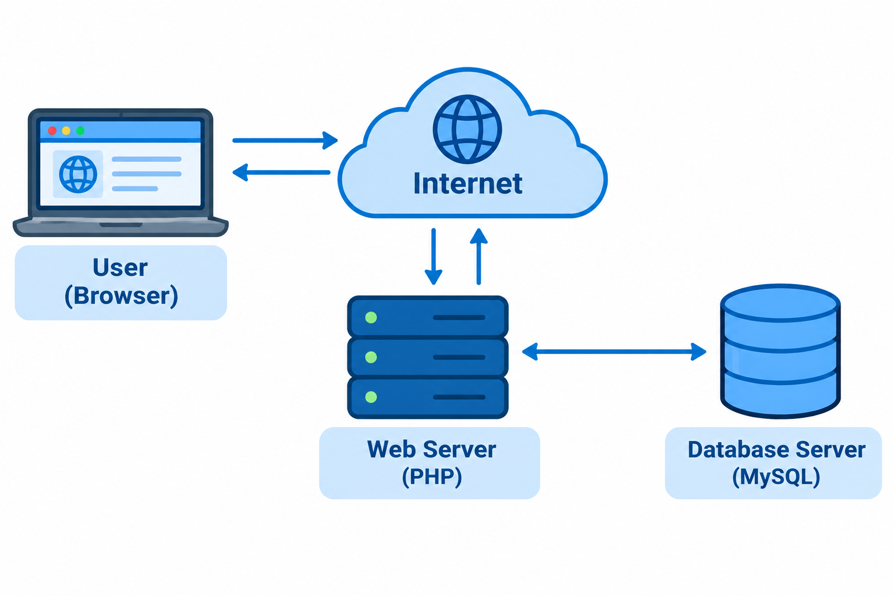
How it works:

1. The user opens the website through a browser.
2. The browser sends a request to a PHP page.
3. PHP processes the request and communicates with MySQL through db_connect.php and MySQLi.
4. MySQL returns the requested information or the result of a database operation.
5. PHP generates the response, which is displayed in the browser.

TECHNOLOGY STACK

Category | Technology Used | Purpose
Programming Language | PHP | Server-side processing, login, registration, sessions, user management
Frontend Markup | HTML | Creates forms, links, tables, page structure
Styling Language | CSS | Controls colors, spacing, typography, layout
Database Language | SQL | Creates database and tables, performs data operations
Database Management System | MySQL | Stores user records
Database Connectivity | MySQLi | Connects PHP to MySQL and executes queries
Session Management | PHP Sessions | Maintains login state between page requests
Framework | None | Uses plain PHP (no framework)

Database Information

Database name: simple_system
Table name: users
Fields: id, username, password, created_at
Primary key: id
Registration timestamp: created_at

DATABASE DESIGN
Database: simple_system

Table: users

Field | Type | Description
id | INT (AUTO_INCREMENT) | Primary key
username | VARCHAR(50) | User’s username
password | VARCHAR(255) | User’s password
created_at | TIMESTAMP | Date and time of registration (default: current timestamp)

SQL Example (database.sql)

CREATE DATABASE simple_system;

USE simple_system;

CREATE TABLE users (
id INT AUTO_INCREMENT PRIMARY KEY,
username VARCHAR(50) NOT NULL UNIQUE,
password VARCHAR(255) NOT NULL,
created_at TIMESTAMP DEFAULT CURRENT_TIMESTAMP
);

SYSTEM FLOWCHART

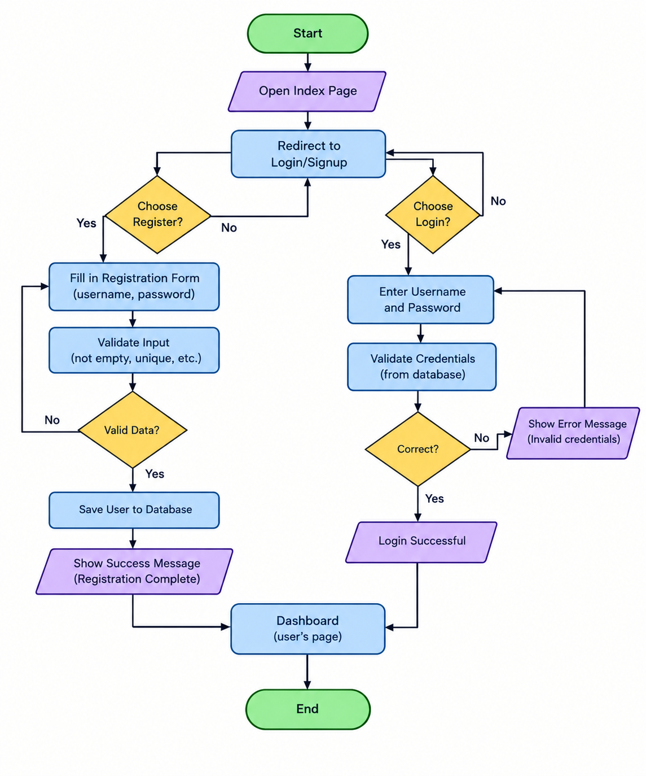

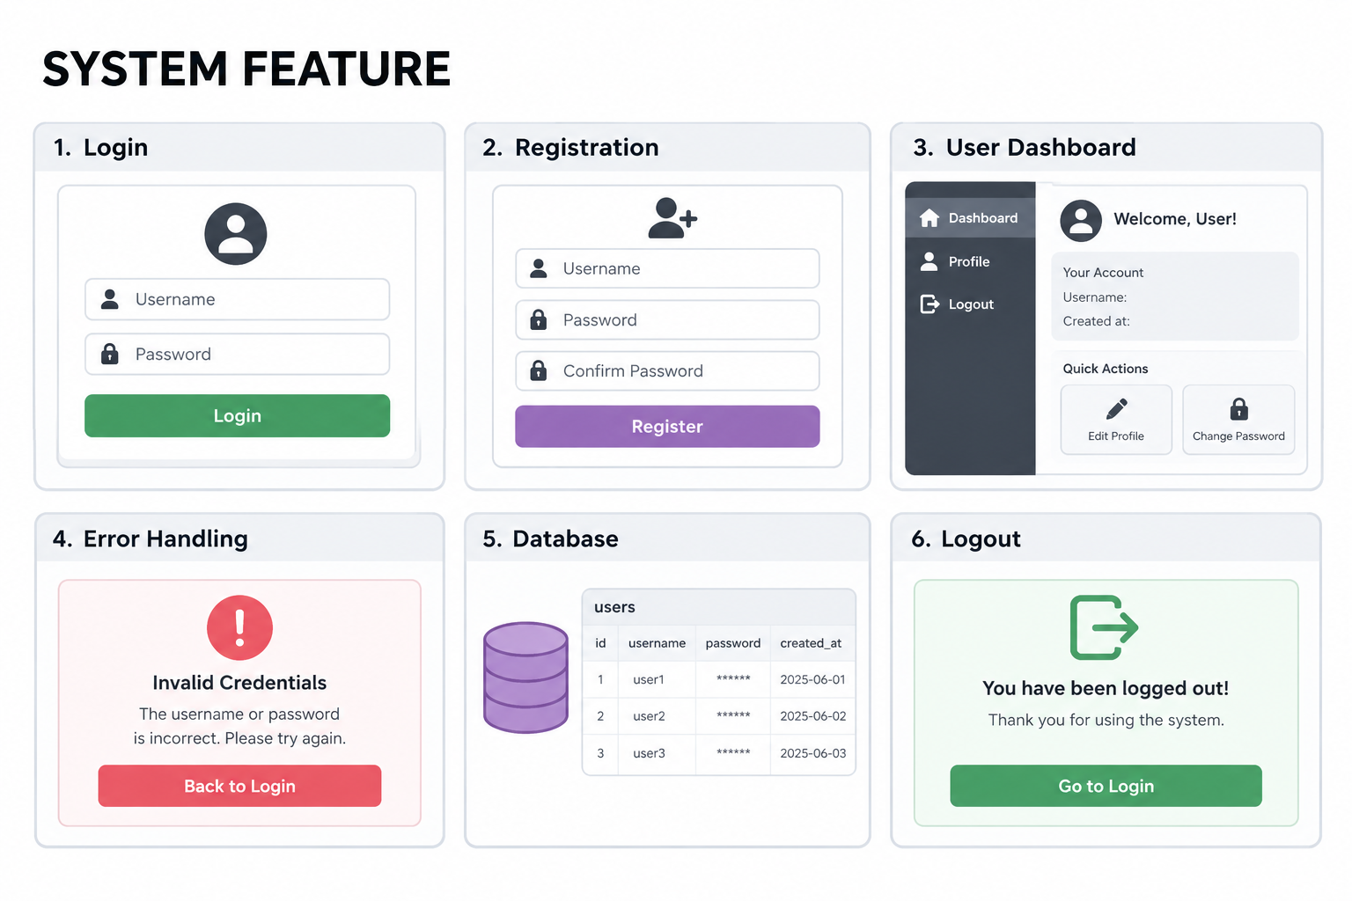

CONCLUSION
The Simple Login System successfully provides a simple and functional way to register, authenticate, and manage user accounts. It demonstrates how PHP, MySQL, HTML, and CSS work together to create a basic web application.

Through this project, we learned how to handle form processing, database connectivity, session management, and basic access control. Although the system is simple, it serves as a good foundation for more advanced features such as password hashing, prepared statements, and better security practices.

